Procedure to turn On and Off the distillation

- Turn On

a) Switch On the chiller by pressing the on button (see figure 1). Note: Two “ON” buttons (Front & back)

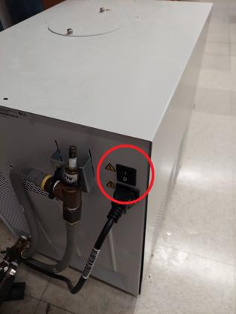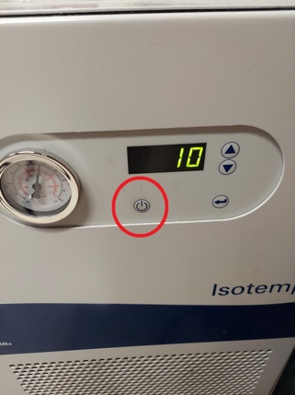
b) Flip both In and Out Valves from horizontal (closed) to vertical (open) (see Figure 2).
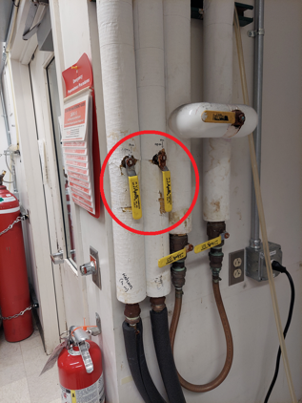
c) wait until the circulating water reaches 10 ºC or lower. The temperature of the water is indicated on the front of the water chiller.
It typically takes 20 minutes for the water to cool down from r.t. down to 10 ºC.
d) For each distillation blocks: (DCM/CHCl₃ – Acetonitrile – Hexanes/Pentane – Toluene/Benzene – THF/Ether)
Open Argon feed at the main tank (Knob circled in green), make sure the tank is NOT empty. Do NOT change the pressure (Knob circled in red)
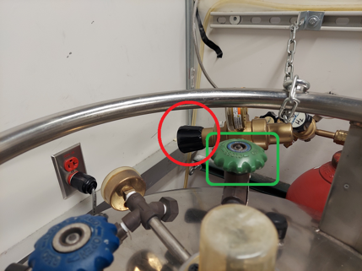
Then, for each distillation, follow the steps below
i. Check the glassware for damages. If no damage is detected proceed to the next step.
ii. Check the oil level of the bubbler and eventually add more mineral oil if needed (flask with mineral oil is located on top of the yellow cabinet V).
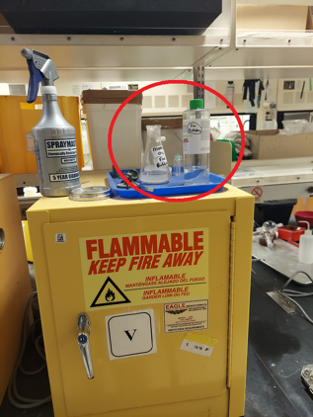
iii. Check that Argon is flowing when turned on.
iii. Adjust the position of the heating mantle if needed.
iv. Check the level of solvent in the bottom flask AND collector. If a particular solvent needs to be refilled/redone, Unplug the still and alert other group members and Mo to either refill or redo the still.
iii. Make sure the top, or both higher stopcocks are in closed position (circled green).
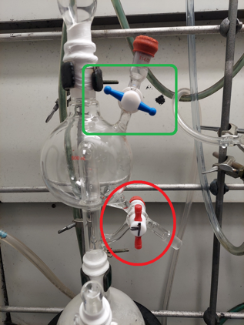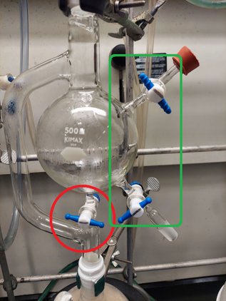
e) For all blocks that passed ALL the checks:
i. Release the solvent in the collector to the bottom flask. (circled red)
ii. Make sure the heating mantel is plugged!
iii. Switch On the alarm unit for that distillation block and move to the next. Distillation.
f) Check all stills every 10-15 minutes until refluxing for any issues while refluxing.
If any issue is noticed, Open Argon until still is cooled back to r.t., Unplug and Remove heating mantle. Alert other group members to correct issue.

Turn Off

- Switch all collector stopcock to closed position. The goal is to collect about half to ¾ of the collector.
Beware to NOT dry the bottom collector. Stop heating (next step) as soon as the solvent level in the bottom flask becomes too low.
- For each still, once collection level has reached desired target level/ or reach safety limit
i. Turn on the Argon flow.
ii. Lower and/or remove the heating mantle.
iii. if other solvents from the same alarm unit are still running, Unplug heating mantle.
iv. when all solvents connected to the same alarm unit (DCM/CHCl3/Acetonitrile – Hexanes/Pentane – Toluene/Benzene/THF/Ether) are stopped, Switch off the corresponding alarm unit, and Replug all heating mantle of that unit.
Repeat for each solvent distills until all are stopped
d) When a heating mantle AND the corresponding bottom solvent flask are cooled down to r.t.:.
i. re-adjust cold heating mantle to its normal position (directly below its corresponding bottom flask).
ii. when all solvents of a block (DCM/CHCl₃ – Acetonitrile – Hexanes/Pentane – Toluene/Benzene – THF/Ether) are cooled down to r.t, turn off the Argon flow of that block.
Repeat for each solvent stills until all are cooled down to r.t, heating mantle positioned back to their respective normal position.
- When all stills are cooled down to r.t, switch off the chiller and Flip both In and Out Valves from vertical (open) to horizontal (closed).

Do not close the main Agron tank unless you are the last one in the lab

